CentRes POS

# **Status Update: Sprint** 3 **– Week** 1

**Submitted by:** S. Andy Short

## **TRELLO BOARD**

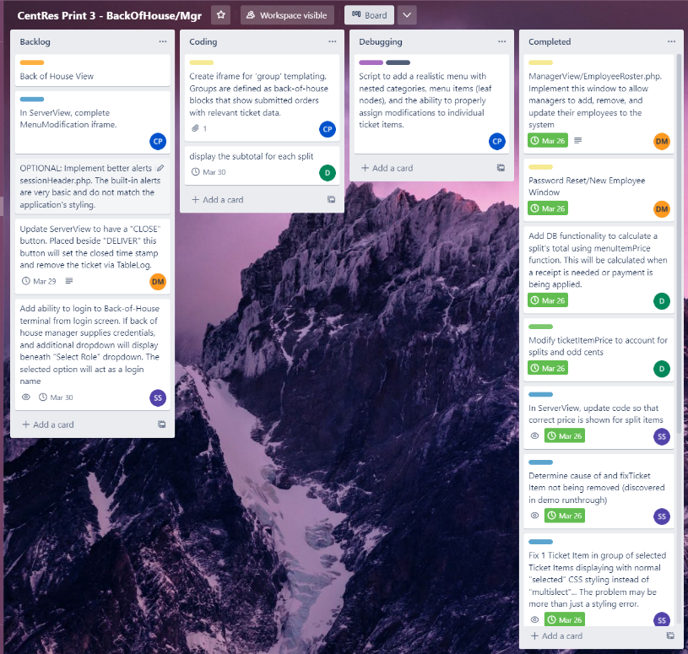

## **STATUS UPDATE DETAILS**

### **Tasks Accomplished**

1. ServerView
   1. Fixed button states not correctly set on ServerView when ticket item was deleted.
   2. Added DELIVERED button. Marks any items for selected ticket that are ready in kitchen as “Delivered.”
   3. Added conspicuous animation to clearly show server an item is ready in kitchen
   4. Changed dynamic Seat values in “Seat” dropdown. The number of seats is now static and is set to the party size.
   5. FINALLY 😊 implemented ticket item split values. DB functions had to be added to achieve this. If a ticket item is split and you have a split selected, the correct price is now displayed. Up to this point, the total price was displayed. It takes into account odd pennies, which are assigned to the lowest number split.

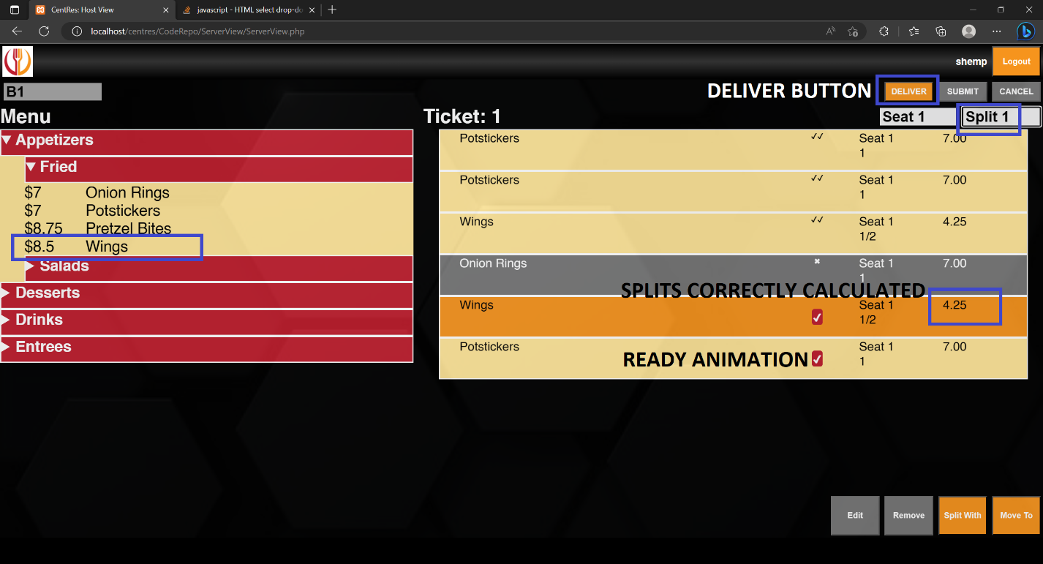

1. Management Views (only accessible to managers)
   1. Implemented EmployeeRoster.php. This window allows you to add and remove employees. It also has an Edit/Add button that routes to NewEditEmployee.php

* 1. Implemented NewEditEmployeeWindow.php This window allows you to create new employee profiles and edit existing ones. The passphrase field allows the manager to set a temporary password for an employee. When the employee logs in with a passphrase, they will be required to reset their password before accessing the application.

1. Login process changes
   1. Login now takes into account passphrases. If an employee logs in with a passphrase, it requires them to change their password before continuing the login process.

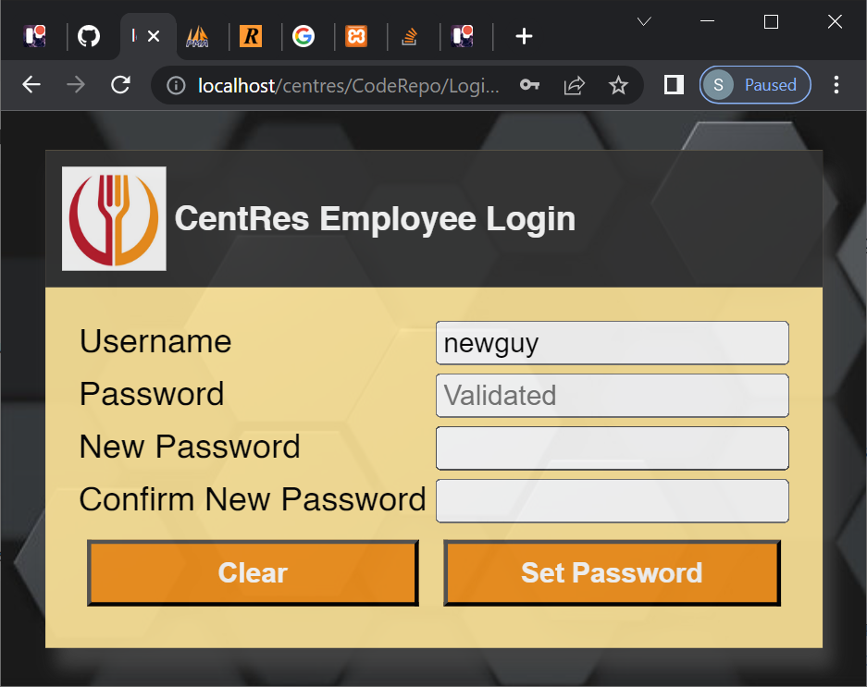

* 1. Login view no longer retains the entered password. It keeps track of the hash and indicates the password has been “Validated”. The stored password hash is also changed each time an employee logs in.
  2. If no manager is in the database when the login page is accessed, you are redirected to CreateAdminView.php. On this page you create an employee profile with maximum permissions. Upon successfully creating this profile, you are redirected back to the login page. The username and password you entered are retained. CreateAdminView cannot be accessed if there is a manager profile defined in the database. It will redirect to login page if this is the case.

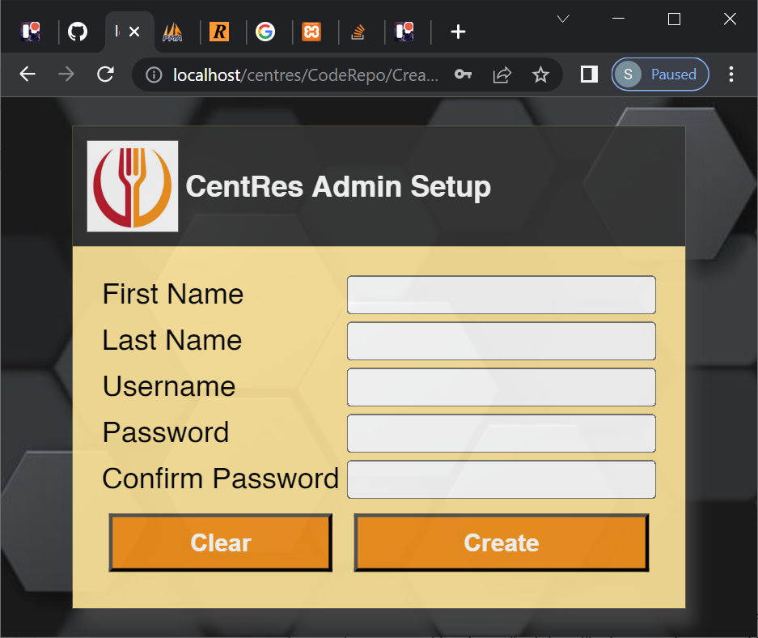

1. General System Constraint changes
   1. UNIQUE constraint was removed from partyName for ticket. It is very likely that in a normal business day the same partyName will be used by different groups of patrons.
   2. Any instance of TINYINT was upgraded to SMALLINT. During our group meeting on 3/23 it was discovered some data, specifically TicketItems.splitFlag, wouldn’t fit into TINYINT.
   3. disaplayInterface.setVar() would set a value if the passed argument was undefined. This was an oversight. It was causing obscure bugs. The implementation was changed to not perform an update if the value was undefined and return a value of false, indicating nothing happened.

### **Problems/Challenges (include status – “resolved/not resolved”)**

1. Invalid button states on ServerView. This problem took a while to resolve. There were 4 faulty code segments that contributed to this problem. After methodical investigation, all of the bad code was recoded to fix this bug. **RESOLVED**

2. Carson pushed a temporary stopgap update to HostView. Some of the restaurant layout was being clipped. His patch has introduced a problem where HostView does not fit on smaller screens. He says the problem has been fixed as well as the original bug. The final solution has not been pushed yet, forcing the status to be **UNRESOLVED**

3. SQL MOD problems. Mysql’s mod function wasn’t working correctly on decimals. We worked around the problem and used TRUNC to calculate split prices for ticket items. **RESOLVED**

4. Incorrect use of TINYINT in database. We were trying to store values that were too large for TINYINT in that data type. We upgraded to using SMALLINT for every instance. **RESOLVED**

5. **UNRESOLVED** Carson has yet to push his menu editor and mod window code. His implementation requires database changes. More than likely there will be difficulties integrating his changes into the application.